HOME PAGE
Welcome to The Nestling Space, a gentle home for your healing and growth. Here, you are seen, heard, and supported as you untangle life’s worries, build emotional strength, and move toward a life of clarity, peace, and purpose.

About

Mission and vision
The Nestling Space is a mental wellness home created for anyone ready to heal, grow, and break free from heavy patterns. We offer gentle, professional support through individual and family counselling, couples and marriage work, group programs, and corporate wellness services.
Rooted in compassion and faith-informed care, we walk with you as you build emotional resilience, heal from trauma, and learn practical tools for everyday life. Here, your story matters, your feelings are valid, and your healing journey is honored.

Services

Individual therapy

Individual therapy at The Nestling Space offers a safe, confidential space to explore your thoughts, feelings, and life experiences. Through one-to-one counselling, we support you in working through stress, anxiety, depression, trauma, grief, and life transitions. Together, we focus on building emotional resilience, breaking negative cycles, and helping you gain clarity and confidence so you can move forward with purpose and hope.

Family Therapy
Family therapy at The Nestling Space creates a supportive space for families to listen, heal, and grow together. We help families navigate conflict, communication breakdowns, parenting challenges, loss, and major life changes. Through guided conversations and practical tools, we work to rebuild trust, strengthen bonds, and create healthier patterns so each family member feels seen, valued, and emotionally safe.”

Couples & marriage Counselling
Couples and marriage counselling at The Nestling Space offers a gentle, neutral space for partners to reconnect and heal. We support couples facing communication breakdown, frequent conflict, betrayal, distance, or major life transitions. Through guided conversations and practical tools, we help you improve communication, rebuild trust, understand each other’s needs, and create healthier patterns so your relationship can feel safer, stronger, and more fulfilling.”

Group Sessions
Group sessions at The Nestling Space bring people together in a safe, supportive setting to share, learn, and heal alongside others with similar experiences. Guided by a qualified therapist, each group focuses on topics such as stress, anxiety, trauma, grief, or life transitions. Together, we explore practical coping tools, build emotional resilience, and reduce feelings of isolation so you feel more understood, empowered, and connected.

1. Individual Counseling
A safe and confidential space where individuals can explore their thoughts, emotions, and life challenges. Individual counseling helps clients manage stress, anxiety, depression, trauma, grief, and personal struggles while developing healthier coping strategies and emotional resilience.

2. Inner Child Healing Therapy
This service helps individuals identify unresolved childhood wounds that may still affect their relationships, emotions, and physical well-being today. Through guided reflection, therapeutic exercises, and emotional processing, clients learn to heal past pain and build healthier patterns for the future.

3. Couples & Marriage Counseling
Designed to help couples improve communication, resolve conflicts, rebuild trust, and strengthen emotional connection. Counseling supports couples navigating challenges such as communication breakdown, infidelity, emotional distance, or preparation for marriage.

4. Family Counseling
Family counseling helps families navigate conflicts, improve communication, and rebuild healthy relationships. Sessions focus on strengthening understanding between family members and addressing issues such as parenting challenges, generational conflict, or family trauma.

5. Trauma & Emotional Healing
Support for individuals who have experienced traumatic events, abuse, loss, or deep emotional wounds. Therapy focuses on helping clients process trauma safely, restore emotional stability, and reclaim a sense of peace and control.

6. Stress, Anxiety & Burnout Support
This service supports individuals experiencing overwhelming stress, anxiety, or emotional exhaustion. Clients learn practical techniques to manage stress, regulate emotions, and restore balance in daily life.

7. Women's Emotional Wellness
A supportive space for women navigating life transitions such as relationship challenges, motherhood, identity struggles, emotional wounds, and personal growth. Counseling helps women rediscover their voice, confidence, and emotional strength.

8. Group Healing Sessions
Facilitated small-group sessions where participants share experiences, gain support, and learn together. Topics may include emotional healing, personal growth, self-awareness, and relational health.

9. Temperament & Personality Understanding
This service helps individuals understand their natural temperament, personality patterns, and emotional responses. By learning how temperament influences behavior and relationships, clients can develop healthier self-awareness and communication.

10. Faith-Based Counseling (Optional if you want)
For individuals who desire spiritual guidance alongside psychological counseling. Sessions integrate biblical principles with therapeutic approaches to support emotional and spiritual healing.

11. Workshops & Personal Development Programs
Educational and therapeutic workshops designed to help individuals grow emotionally and relationally. Topics may include:
- Healing the Inner Child
- Emotional Intelligence
- Healthy Relationships
- Boundaries and Assertiveness
- Stress Management

12. Online Counseling
Secure virtual counseling sessions for individuals who prefer remote support or live outside the local area. Online sessions provide the same confidential and supportive environment as in-person sessions

Refund Policy
Nestling Space
At Nestling Space, we are committed to providing a safe, supportive, and professional experience for all clients. This Refund Policy outlines how payments, cancellations, and refunds are handled.

1. Session Payments
All counseling sessions must be paid for in advance to secure your booking. Payments confirm your appointment time and therapist availability.

2. Cancellation & Rescheduling
We understand that unexpected situations may arise.
- Cancellations or rescheduling requests must be made at least 24 hours before your scheduled session.
- If you cancel within this timeframe, you may:
  - Reschedule your session at no additional cost, or
  - Request a full refund

3. Late Cancellations
- Cancellations made less than 24 hours before the session are non-refundable.
- However, in exceptional circumstances, Nestling Space may allow rescheduling at its discretion.

4. Missed Appointments (No-Show)
- If you do not attend your session without prior notice, the session is considered a no-show.
- No-shows are non-refundable and cannot be rescheduled.

5. Refund Processing
- Approved refunds will be processed within 5–10 business days.
- Refunds will be issued using the original payment method where possible.
- Please note that any applicable transaction or processing fees may be deducted from the refund amount.

6. Online Sessions
- If technical issues occur on our side that prevent the session from taking place, you will be offered:
  - A full refund, or
  - A rescheduled session at no additional cost
- If the issue is on the client’s side (e.g., internet connectivity), refunds may not be guaranteed.

8. Emergency & Compassion Consideration
We recognize that life can be unpredictable. In cases of emergencies or serious circumstances, refund or rescheduling requests will be reviewed with care and compassion.

9. Policy Agreement
By booking a session with Nestling Space, you acknowledge that you have read and agreed to this Refund Policy.

💡 Optional Add-On (Recommended for Trust):
You can add a gentle closing line:
Our goal is to create a safe and respectful space for both clients and practitioners. This policy helps us honor your time while also respecting the commitment required to provide quality care.

Terms and Conditions
Nestling Space
Last updated: [today]
Welcome to Nestling Space. By accessing our website or booking our services, you agree to the following Terms and Conditions. Please read them carefully.

1. Services Provided
Nestling Space offers counselling, emotional wellness support, and personal development services. These services are intended to support mental and emotional well-being but do not replace medical or psychiatric care.

2. Eligibility
- Clients must be 18 years or older to book sessions independently.
- Individuals under 18 must have parental or guardian consent.

3. Appointments & Bookings
- All sessions must be booked in advance.
- Appointment times are confirmed only after payment is received.
- Clients are responsible for attending sessions on time.

4. Payments
- All services must be paid for in advance unless otherwise agreed.
- Fees are subject to change, but any changes will not affect already confirmed bookings.

5. Cancellation & Refunds
- Cancellations must be made at least 24 hours in advance.
- Late cancellations and missed appointments may not be refunded.
- Please refer to our Refund Policy for full details.

6. Confidentiality
Nestling Space respects client confidentiality. All information shared during sessions will be kept private except where:
- There is risk of harm to yourself or others
- There is suspected abuse or neglect
- Disclosure is required by law

7. Client Responsibility
Clients agree to:
- Provide accurate and honest information
- Participate actively in sessions
- Take responsibility for their own decisions, actions, and outcomes

8. Not a Crisis Service
Nestling Space does not provide emergency or crisis services.
If you are in immediate danger or experiencing a crisis, please contact:
- Local emergency services
- A hospital or mental health professional

9. Online Sessions
- Clients are responsible for ensuring a stable internet connection and a private space.
- Nestling Space is not liable for disruptions caused by factors beyond its control.

10. Intellectual Property
All content on this website (text, branding, materials) belongs to Nestling Space and may not be copied, reproduced, or distributed without permission.

11. Limitation of Liability
Nestling Space is not liable for:
- Decisions or actions taken by clients following sessions
- Indirect or consequential outcomes of counseling services
All services are provided in good faith to support personal growth and well-being.

12. Changes to Terms
Nestling Space reserves the right to update these Terms and Conditions at any time. Updates will be posted on this page.

13. Contact Information
If you have any questions about these Terms and Conditions, please contact:
Nestling Space
nestlingspace@gmail.com
[+263773214886, +2637828030]

💡 Optional softer closing line (good for your brand tone):
At Nestling Space, we are committed to creating a safe, respectful, and supportive environment where healing and growth can take place.

OUR PRACTICE

The Nestling Space is a mental health and emotional wellness practice based in Harare, dedicated to creating a safe, compassionate place for healing and growth. We walk alongside children, teens, adults, couples, and families as they navigate life’s challenges and transitions.
Our work is grounded in evidence-based counselling approaches, a deep respect for each person’s story, and an understanding of the unique pressures faced in our local context. Whether you are dealing with anxiety, depression, trauma, grief, relationship strain, or burnout, we hold space for your pain while helping you build new patterns of hope.
We offer individual and family counselling, marriage and relationship support, parenting guidance, and youth-focused emotional intelligence support. We also partner with schools, churches, and organisations to provide workshops, corporate mental health programs, and group support spaces that strengthen emotional resilience in communities.
At The Nestling Space, we believe that healing is possible, cycles can be broken, and you can move towards a life of clarity, stability, and purpose. You do not have to do it alone—this is a place where you are seen, heard, and supported as you grow.

Testimonials

Discover how Nestling space with Dr. M. Mugabe has positively impacted the lives of our clients through their testimonials.

Peter, a happy student | “Ndainzwa kurasika uye kushungurudzika, ndaifunga kuti vabereki havandidi, uye ndainetseka kuregerera vaninditadzira, asi Nestling Space yakandibatsira kupora uye kudzoka kuziva kukosha kwangu nekukwanisa kuyanana nevabereki vangu.”
Tariro, Satisfied Client | “Before coming to Nestling Space, I felt completely overwhelmed and alone. I was struggling with anxiety and didn’t know how to talk about it. Through the sessions, I learned how to understand my emotions and cope in a healthy way. For the first time in a long time, I feel heard, supported, and hopeful about my future.
T & K , happy | Tisati tawanana, Takauya kuNestling Space tichifunga kuti takagadzirira kuroorana, asi takadzidza zvakawanda pamusoro pekutaurirana, kugadzirisa kusawirirana, uye kunzwisisana. Zvatakadzidza zvakatipa hwaro hwakasimba hwehupenyu hwedu hwewanano.”
Bruno & Yusi, Happy Couple | “We were at a point where communication had completely broken down in our marriage. Every conversation turned into conflict. Nestling Space helped us understand each other again, rebuild trust, and learn healthy ways to communicate. Our relationship is now stronger, and we feel more connected than ever.”
Munenyasha, Healed client | After my breakup, I felt lost, rejected, and emotionally drained. I struggled to make sense of everything and started doubting myself. Nestling Space gave me a safe place to heal and rebuild. Through the sessions, I learned to process my pain, regain my confidence, and rediscover my worth. Today, I am stronger, more self-aware, and at peace with my journey.”

service inquiry
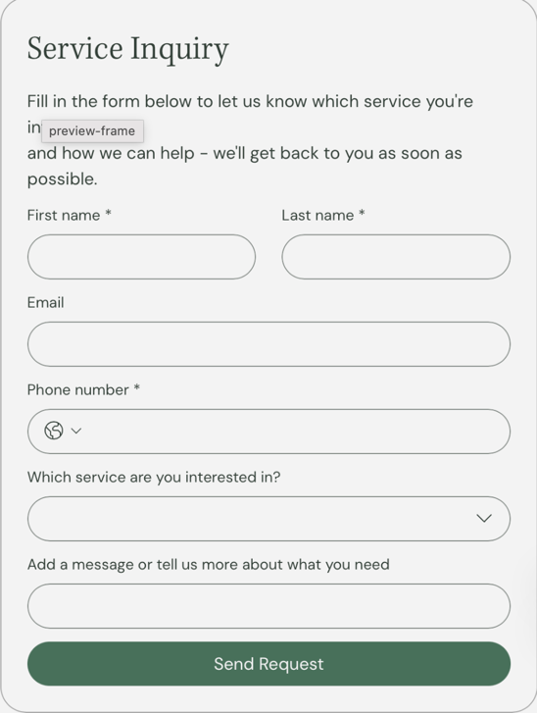

when you sign in you consent to the nestling space terms and conditions

Privacy policy
Welcome to The Nestling Space. Your privacy matters deeply to us. This Privacy Policy explains how we collect, use, and protect your personal information when you use our website and mental health services.
Who We Are
The Nestling Space is a mental health and wellness practice providing counselling, emotional support, and personal growth services in a safe, confidential environment.
Information We Collect
We may collect and process the following information:
Personal Information
- Full name
- Email address
- Phone number
- Appointment details
Sensitive Information
As part of providing mental health support, we may collect:
- Emotional and psychological information
- Personal experiences shared during sessions
- Counselling session notes (kept strictly confidential)
Website Data
- IP address
- Browser type
- Pages visited
- Time spent on our website
How We Use Your Information
We use your information to:
- Provide counselling and wellness services
- Schedule and manage appointments
- Communicate with you (responses, reminders, updates)
- Improve our website and services
- Maintain secure internal records
Confidentiality and Data Protection
At The Nestling Space, your information is handled with the highest level of care.
We ensure:
- Secure storage of all data
- Restricted access to authorized personnel only
- Protection against unauthorized access or disclosure
We do not sell, rent, or share your personal data with third parties.

When We May Share Information
Your information may only be disclosed:
- With your explicit consent
- When required by law
- If there is a risk of harm to yourself or others
- In cases involving abuse or safeguarding concerns

Cookies and Website Tracking
Our website may use cookies to:
- Enhance your browsing experience
- Understand how visitors use our site
- Improve performance and content
You can disable cookies through your browser settings.
Your Rights

You have the right to:
- Access your personal information
- Request corrections
- Request deletion of your data (where applicable)
- Withdraw consent at any time

Data Retention
We keep your information only as long as necessary to:
- Provide our services
- Meet legal and professional obligations

Third-Party Services
We may use secure third-party tools (such as booking systems or email platforms) to support our services. These providers are expected to maintain strong data protection standards.

Children’s Privacy
Our services are not provided to individuals under 18 without consent from a parent or guardian.

Updates to This Privacy Policy
We may update this Privacy Policy occasionally. Changes will be posted on this page with an updated effective date.

Contact Us
If you have questions about this Privacy Policy, please contact:

Face book
Nestling space: mental health & wellness
LinkedIn

Instagram

You tube

copy what you may need on this foot
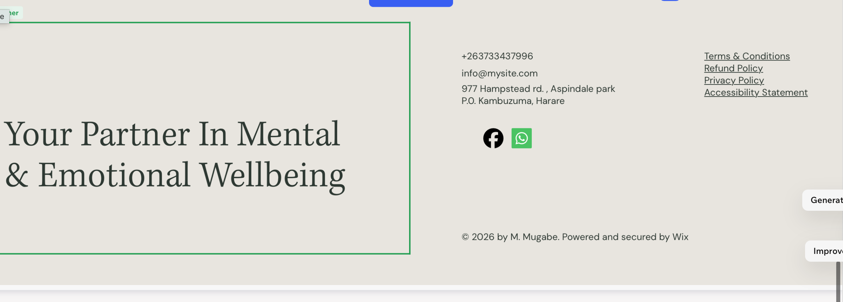

Contact us

We're here to help! If you have any questions, feedback, or need assistance, please don't hesitate to reach out. You can contact us through the form below or email us directly. We look forward to hearing from you!

BOOKINGS PAGE
Booking form
THIS IS FOR YOU TO SEE WHAT INFORMATION YOU CAN MAKE OUT OF THE BOOKING PAGE
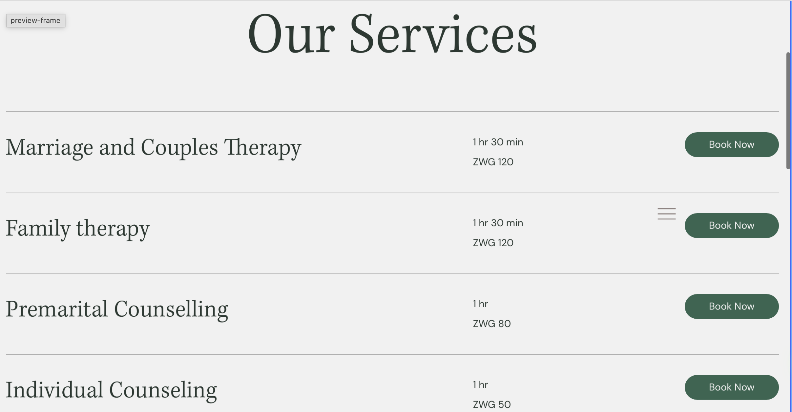

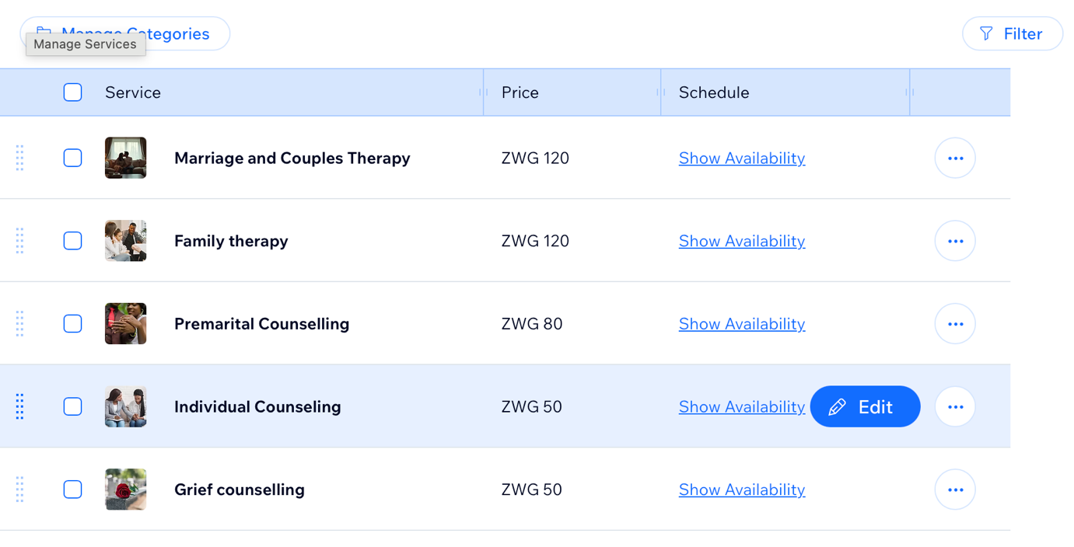

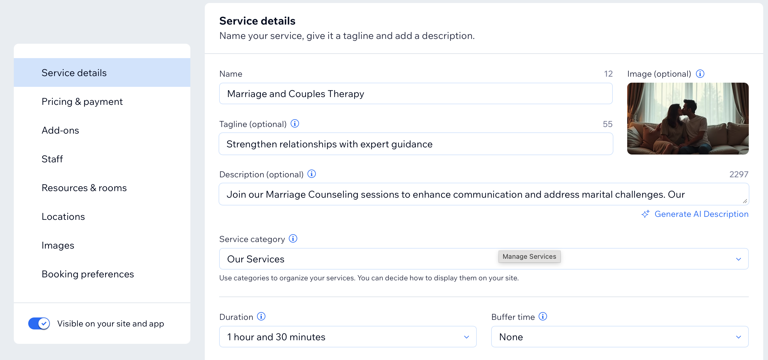

EVENTS PAGES

BLOGS PAGES
1-POSTS
2-BLOG

